**Scott Requirements and Solutions**

1. **Hide all the information of the project**

the freelancer can only see the title of project and the description

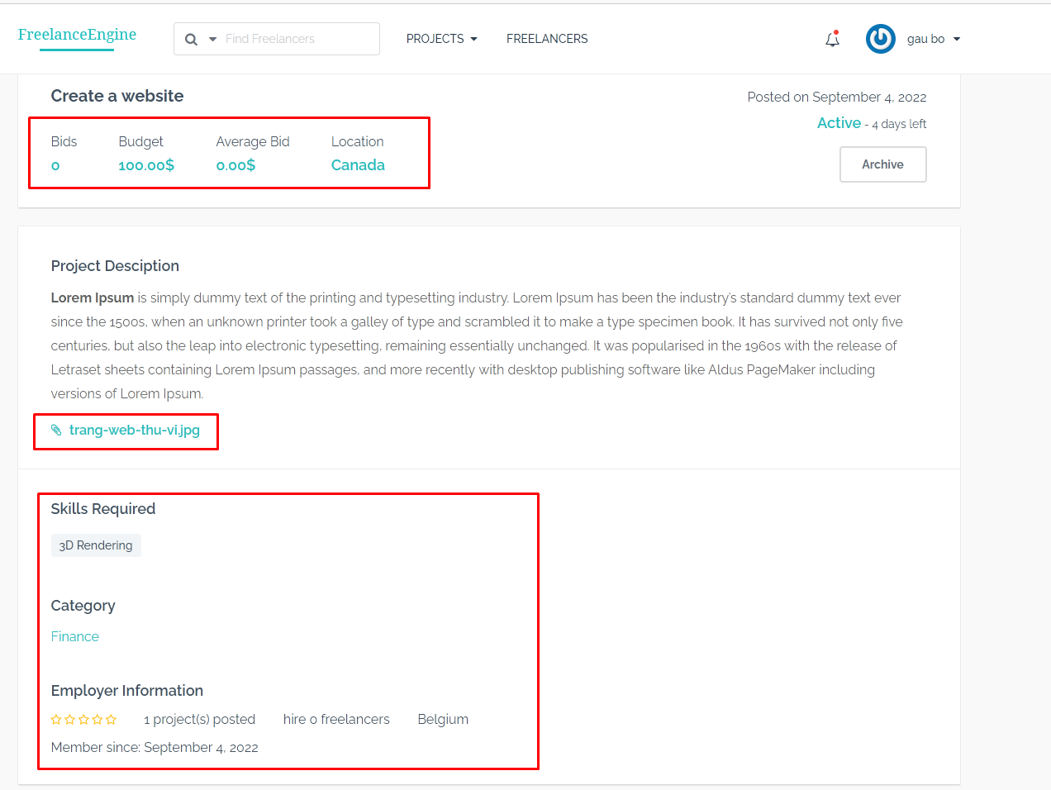

The freelancer can not see the bids , budget , avergage bid, location, images , Skills required, Category, employer information,..

The freelancer will see like this without invitation :

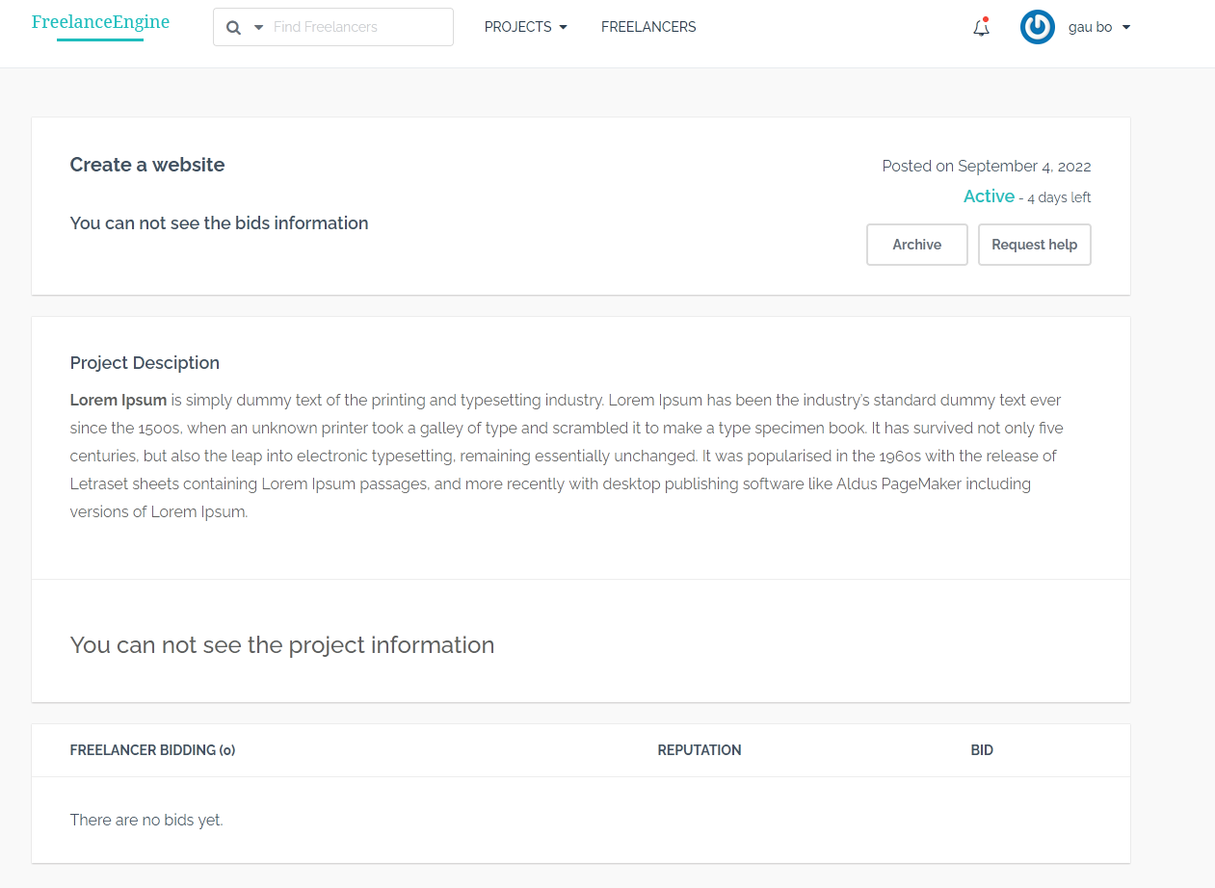

If you want I can only display the title of the project and some part of the project ( not full )

1. **Build a user list and display the custom fields like this ( will discuss more ) and add the capability to invite the freelancer to bid for admin.**

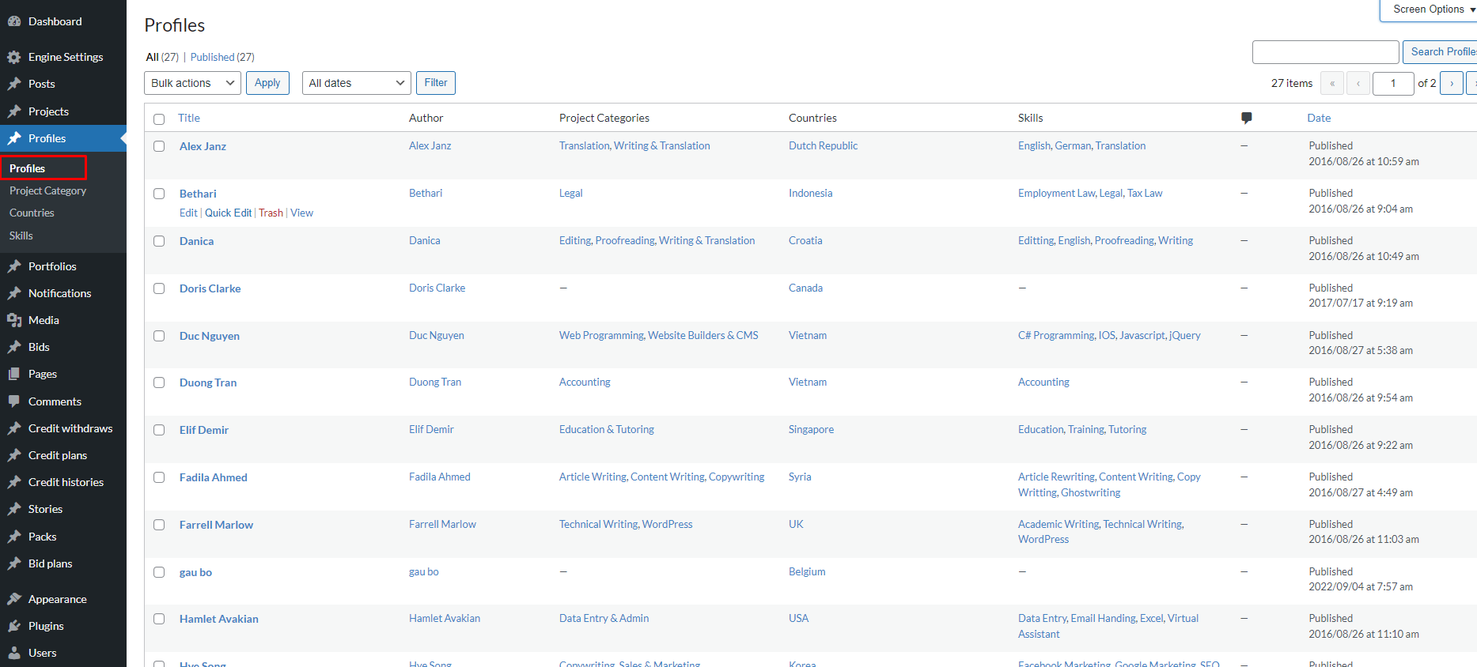

Admin can see and click to a user to go to profile page and send invitation like this:

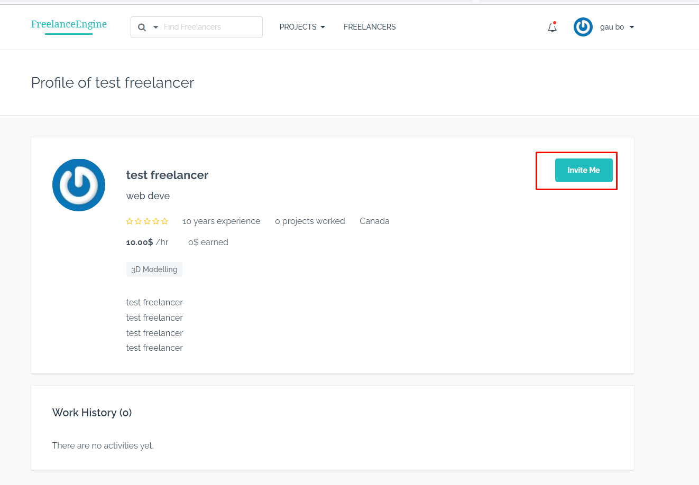

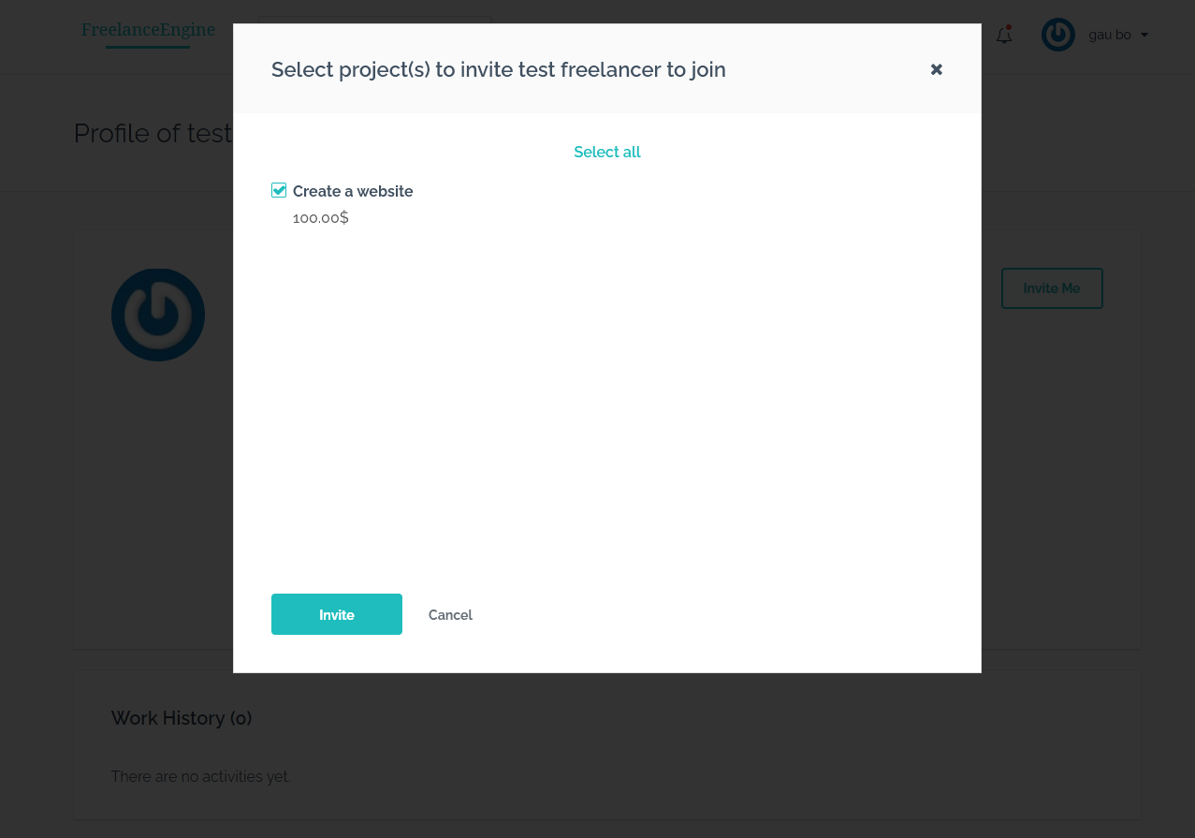

The invitation will be sent as notification :

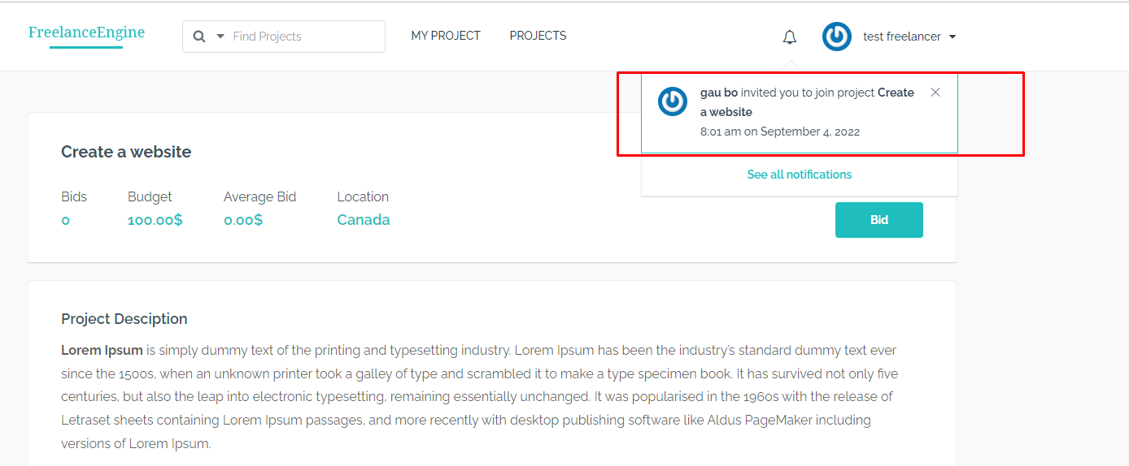

1. **About bid option :**

You want 2 options :

First : employers will invite freelancers to bid ( this is the default of FreelanceEngine ).

Second : employer will request support from admin to review freelancers and invite them to bid 🡪 they will pay the fee

We can add a button like this Request help :

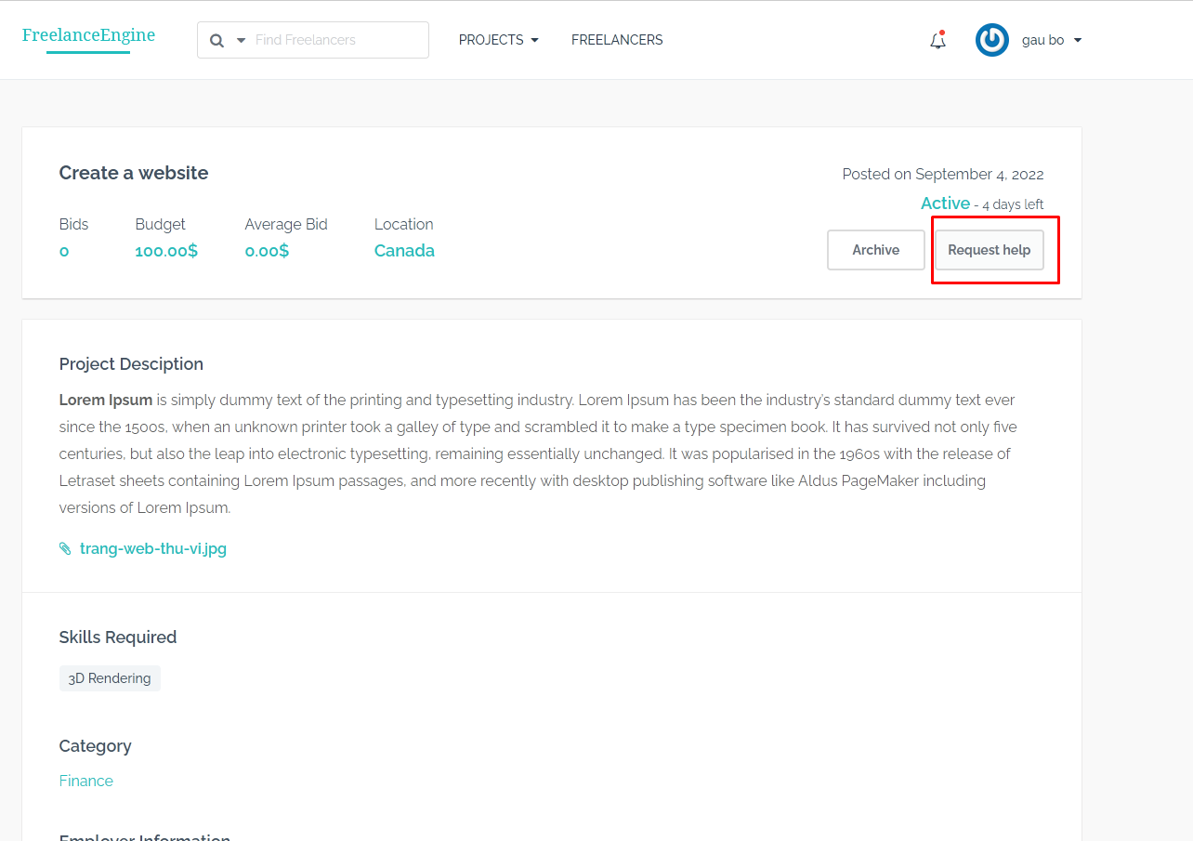

When the employer click to that button, they will be redirected a page and that page will show information like this ( we will discuss about the layout) :

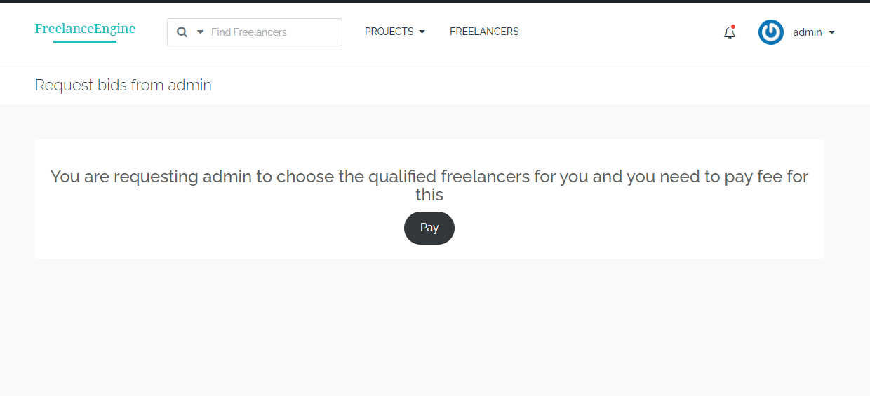

You ( admin ) can set this fee in admin dashboard ( I will this option to admin dashboard )

**Note :The users can only use credit to pay the fee**

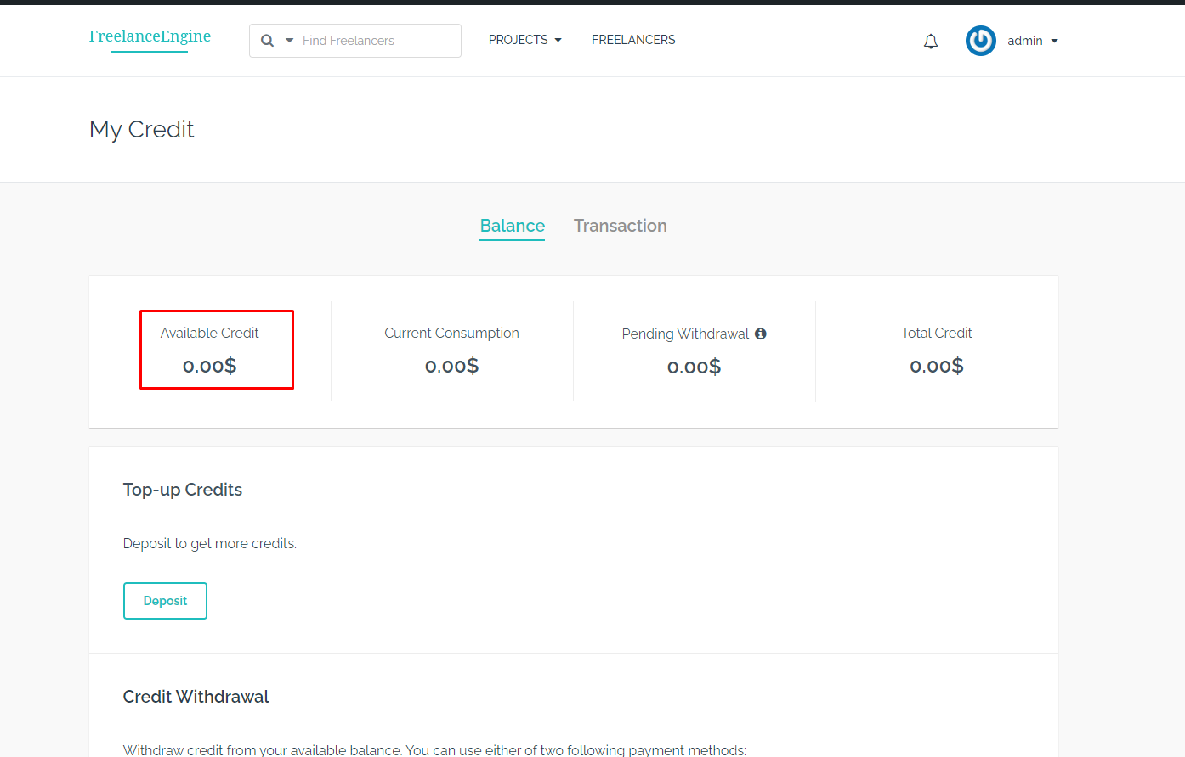

I will also build a request list in admin dashboard so you can check the request list.

The employer will receive a notification after pay the fee.

The employer can also check the status of the request.

The admin also receive an notification email about the request.

Questions :

1. Do you need the custom fields for projects and profile of the freelancers ?